LDA

Results of Logistic Discrimination Algorithm:

**For Dataset 1:**

**Batch Learning:**

Learning Rate: 0.001

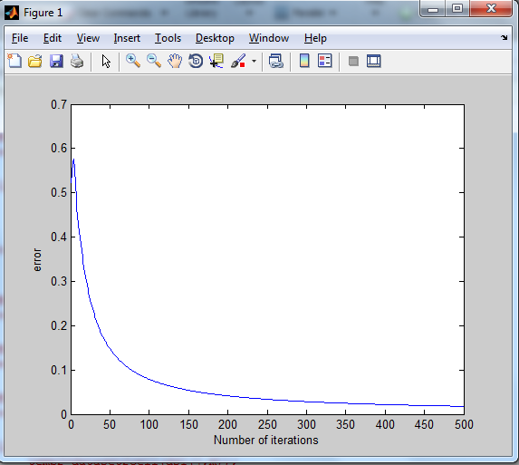

The output shows that the algorithm will require more than 500 iterations to converge to an error closer to 0.

Learning Rate: 0.01

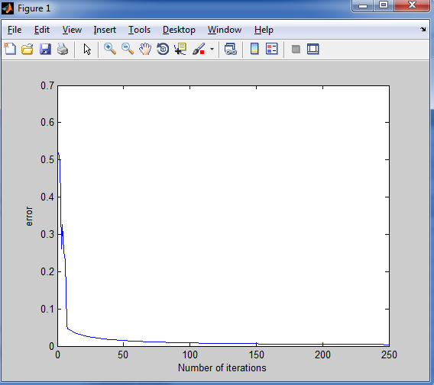

We can observe the error value converge closer to zero at a higher rate.

Learning Rate: 0.1

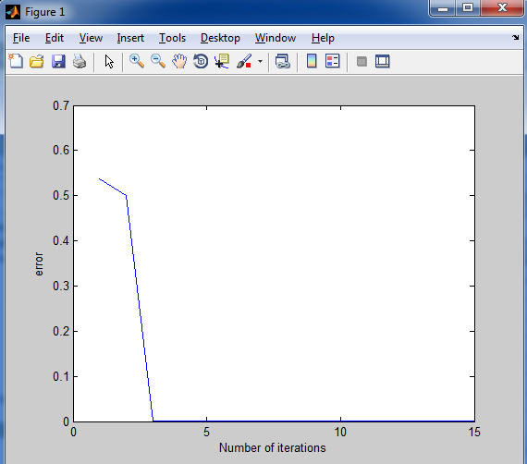

The error value converges closest to zero at the third iteration.

Learning Rate: 0.5

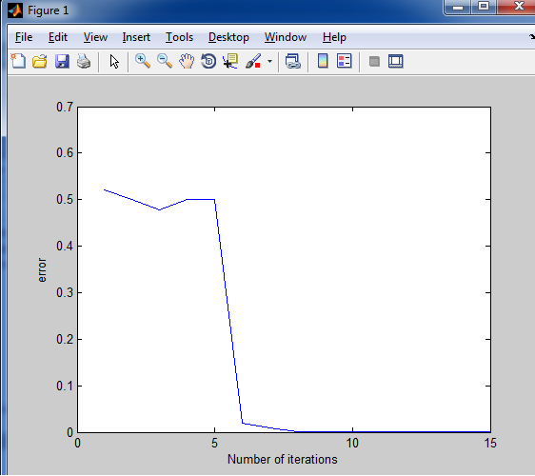

The error value converges closest to zero by the 7th iteration.

**Online Learning:**

Learning Rate: 0.001

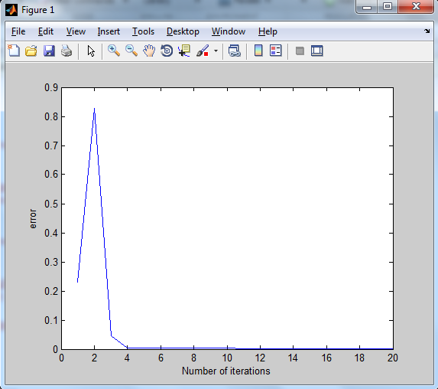

The error value converges to zero by the 15th iteration.

Learning Rate: 0.01

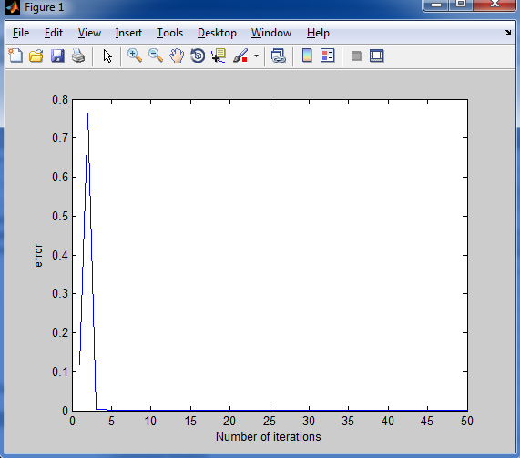

The error value spikes upto 0.75 and then decreases gradually to converge to zero.

Learning Rate: 0.1

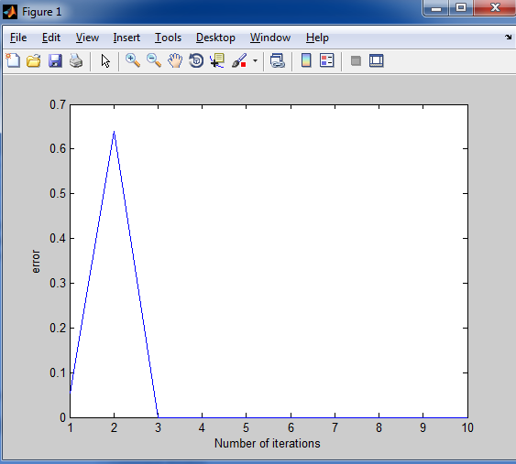

The error value spikes to 0.65 and then decreases instantaneously to zero.

Learning Rate: 0.5

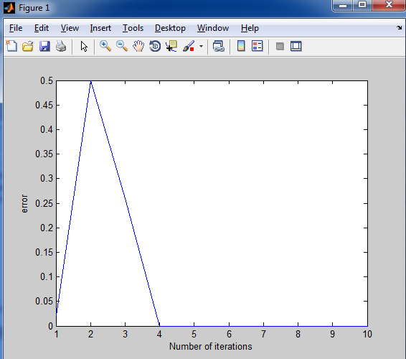

**For Dataset 2:**

**Batch Learning:**

Learning Rate: 0.001

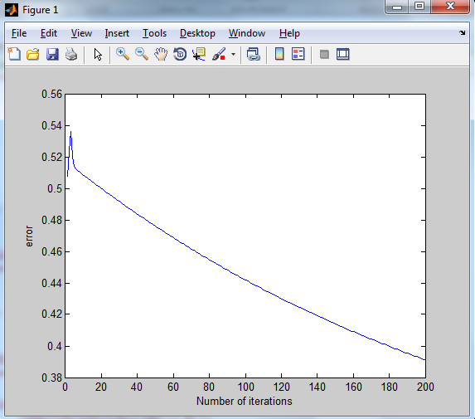

We can observe that the error value will require no less than 700 iterations to converge closer to zero.

Learning Rate: 0.01

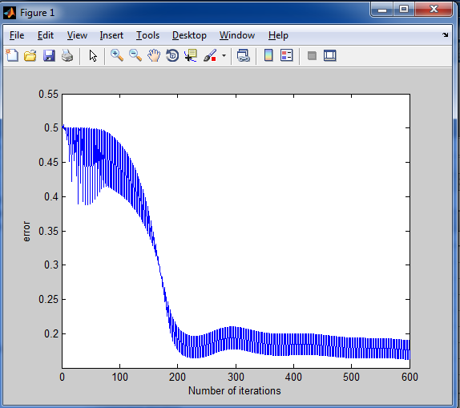=

The error value is observed to be fluctuating continually along with a gradual decrease in the value.

Learning Rate: 0.1

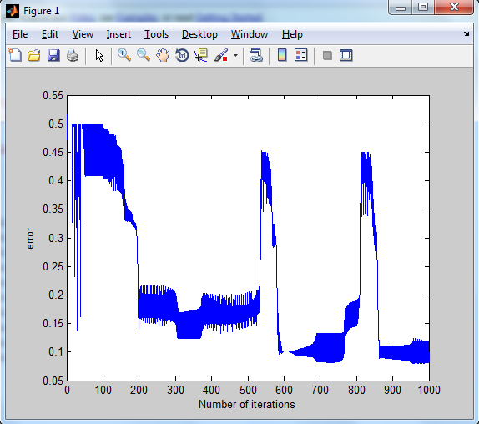

There is a high fluctuation in the error value, along with a constant decrease in the value.

Learning Rate: 0.5

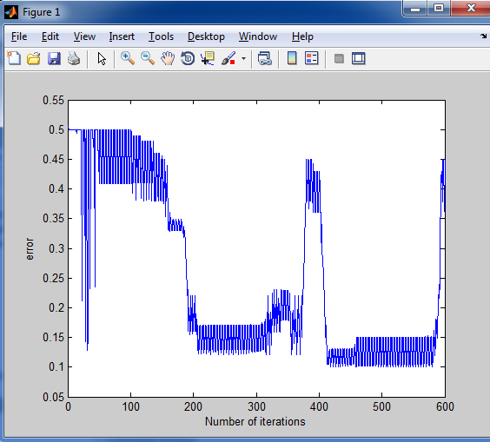

**Online Learning:**

Learning Rate: 0.001

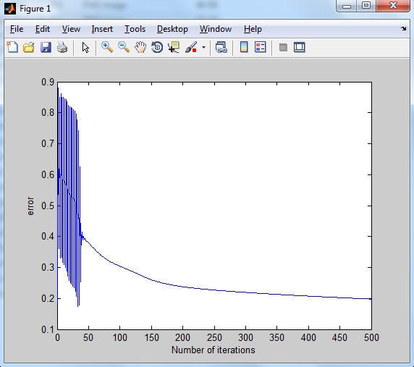

After a high fluctuation in the error value, we can observe a gradual decrease in it. The number of iterations required for a convergence closer to zero will be very high, between 1500 to 2000 iterations.

Learning Rate: 0.01

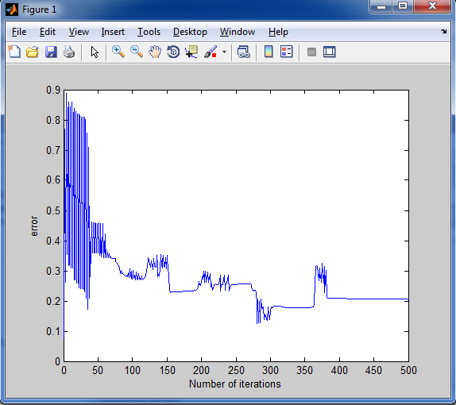

Learning Rate: 0.1

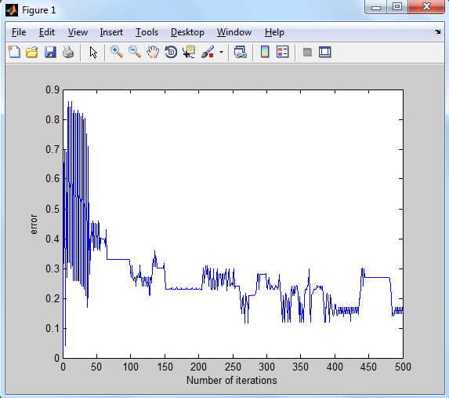

Learning Rate: 0.5

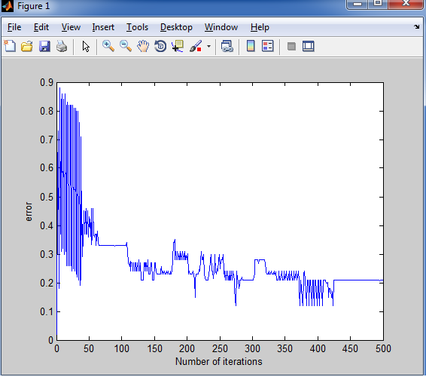

In general, we can observe that there is a high initial fluctuation in the error value, before the algorithm finds gradual descent in the error value.

The overall number of iterations observed in online learning is higher than those required in batch learning.